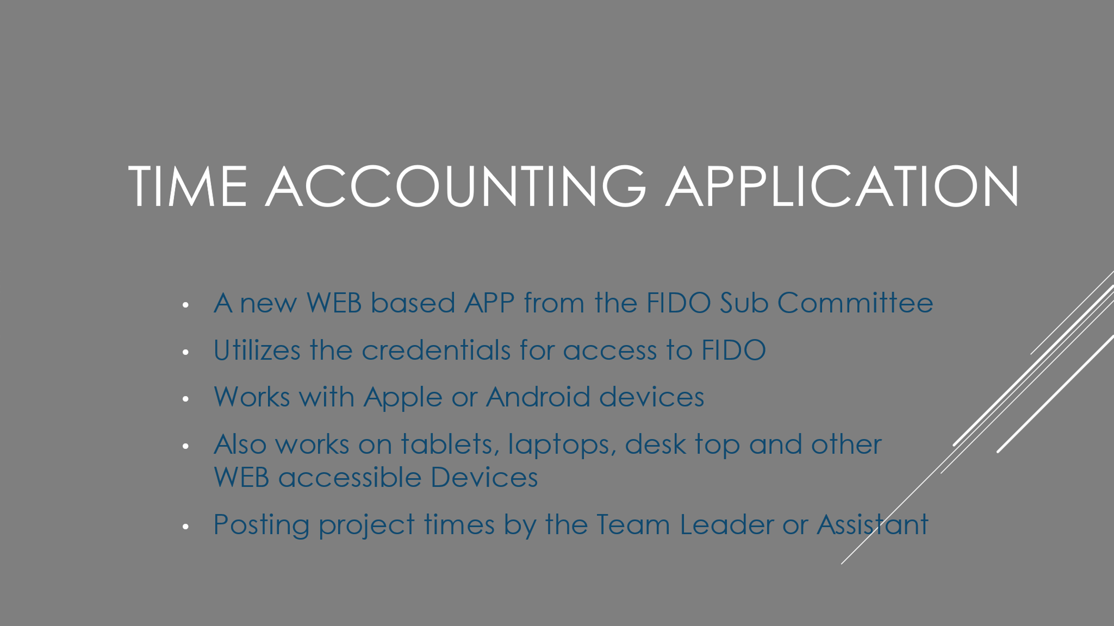

The time accounting application is a new way of keeping track of volunteer’s hours worked. It is very important to the organization as it helps us to keep track of hours spent on projects. This is very important when approaching outside organizations for financial support.

It works with Apple or Android devices and tablets, laptops, desktops or any device that will connect to the web.

How to use the application:

On your web-connected device, go to: <https://fctsfido.org/hours/>

(Note: If you are having trouble reaching the app, try using Firefox or Chrome browsers)

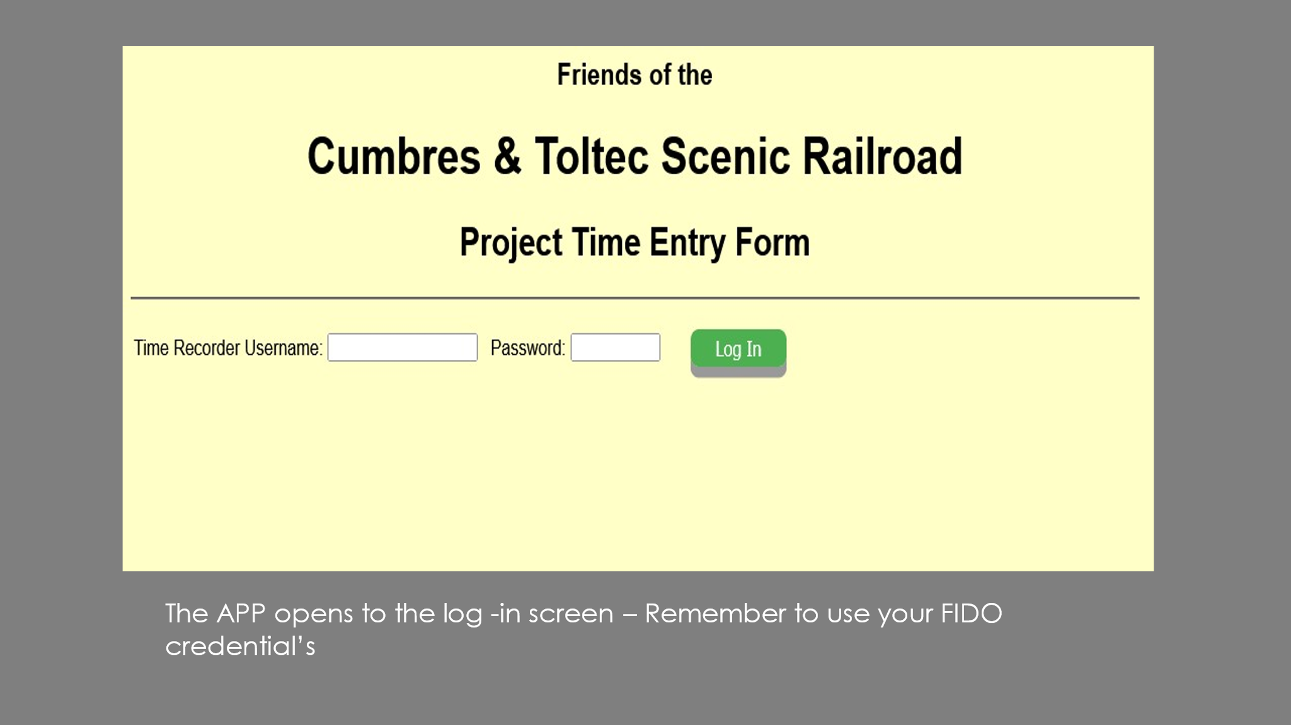

The timecard application opens to the login screen which looks very similar to the regular FIDO screen. The username and password are the same as you would use for the main FIDO login.

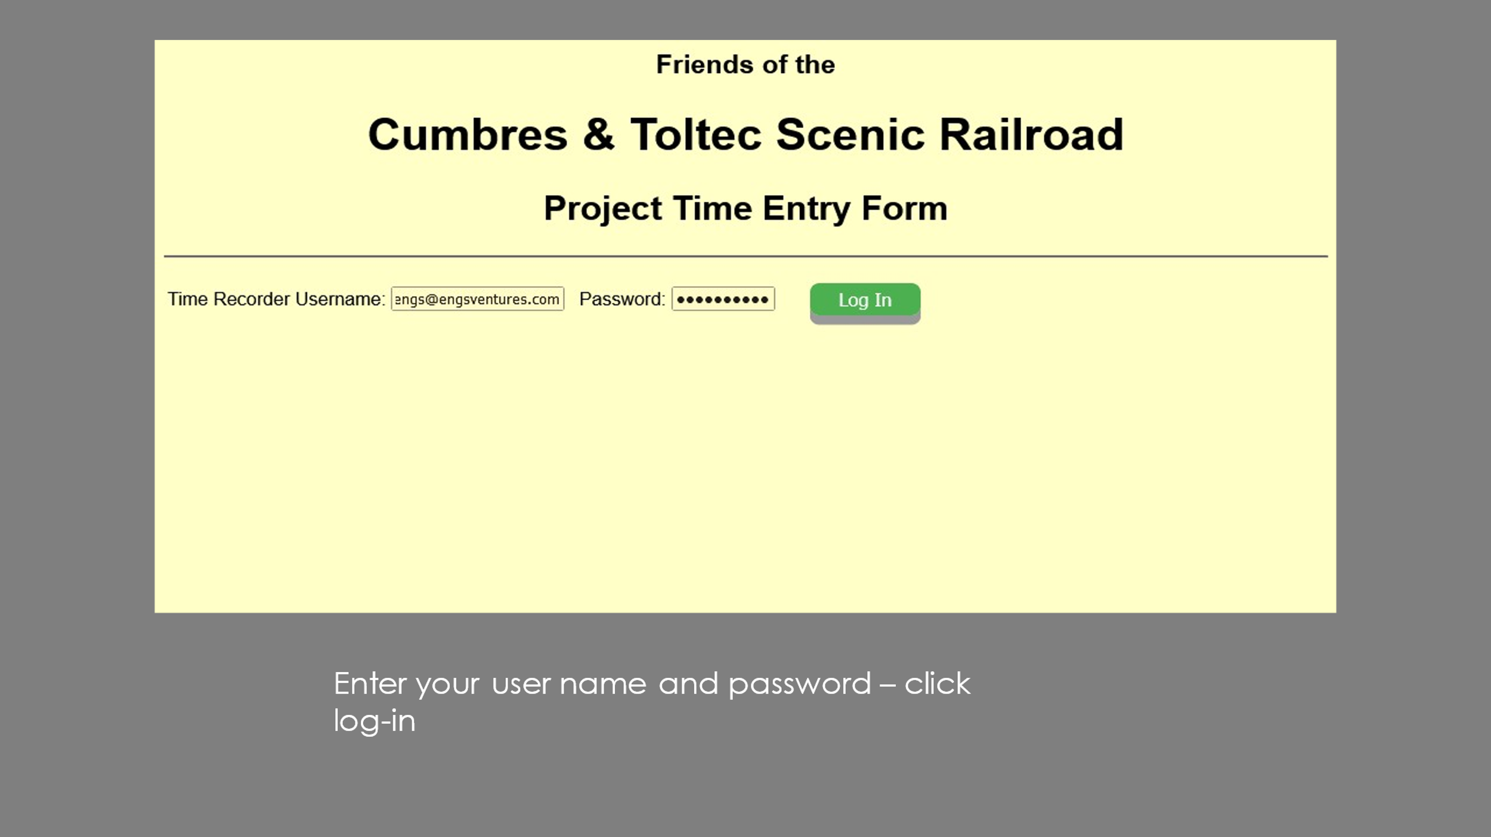

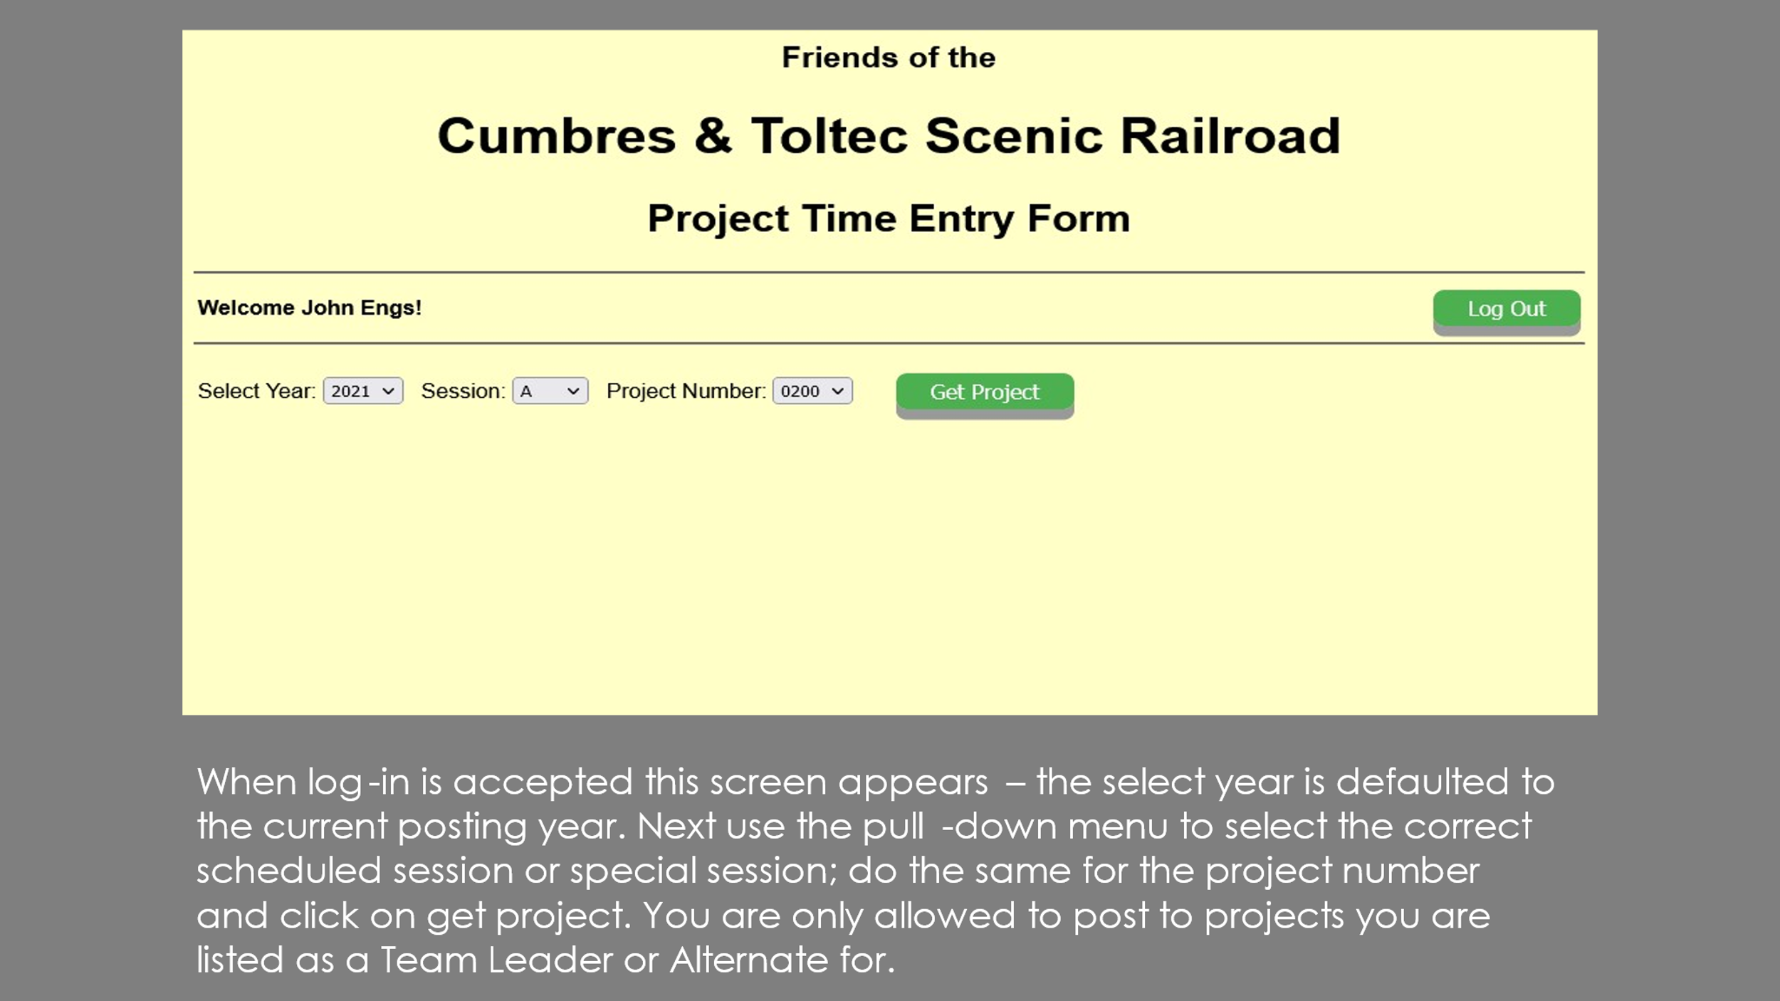Enter your username and password and login.

When your login is accepted, this screen appears. The year defaults to the current posting year. Select the session, followed by the project number. Then click on ‘Get Project’.

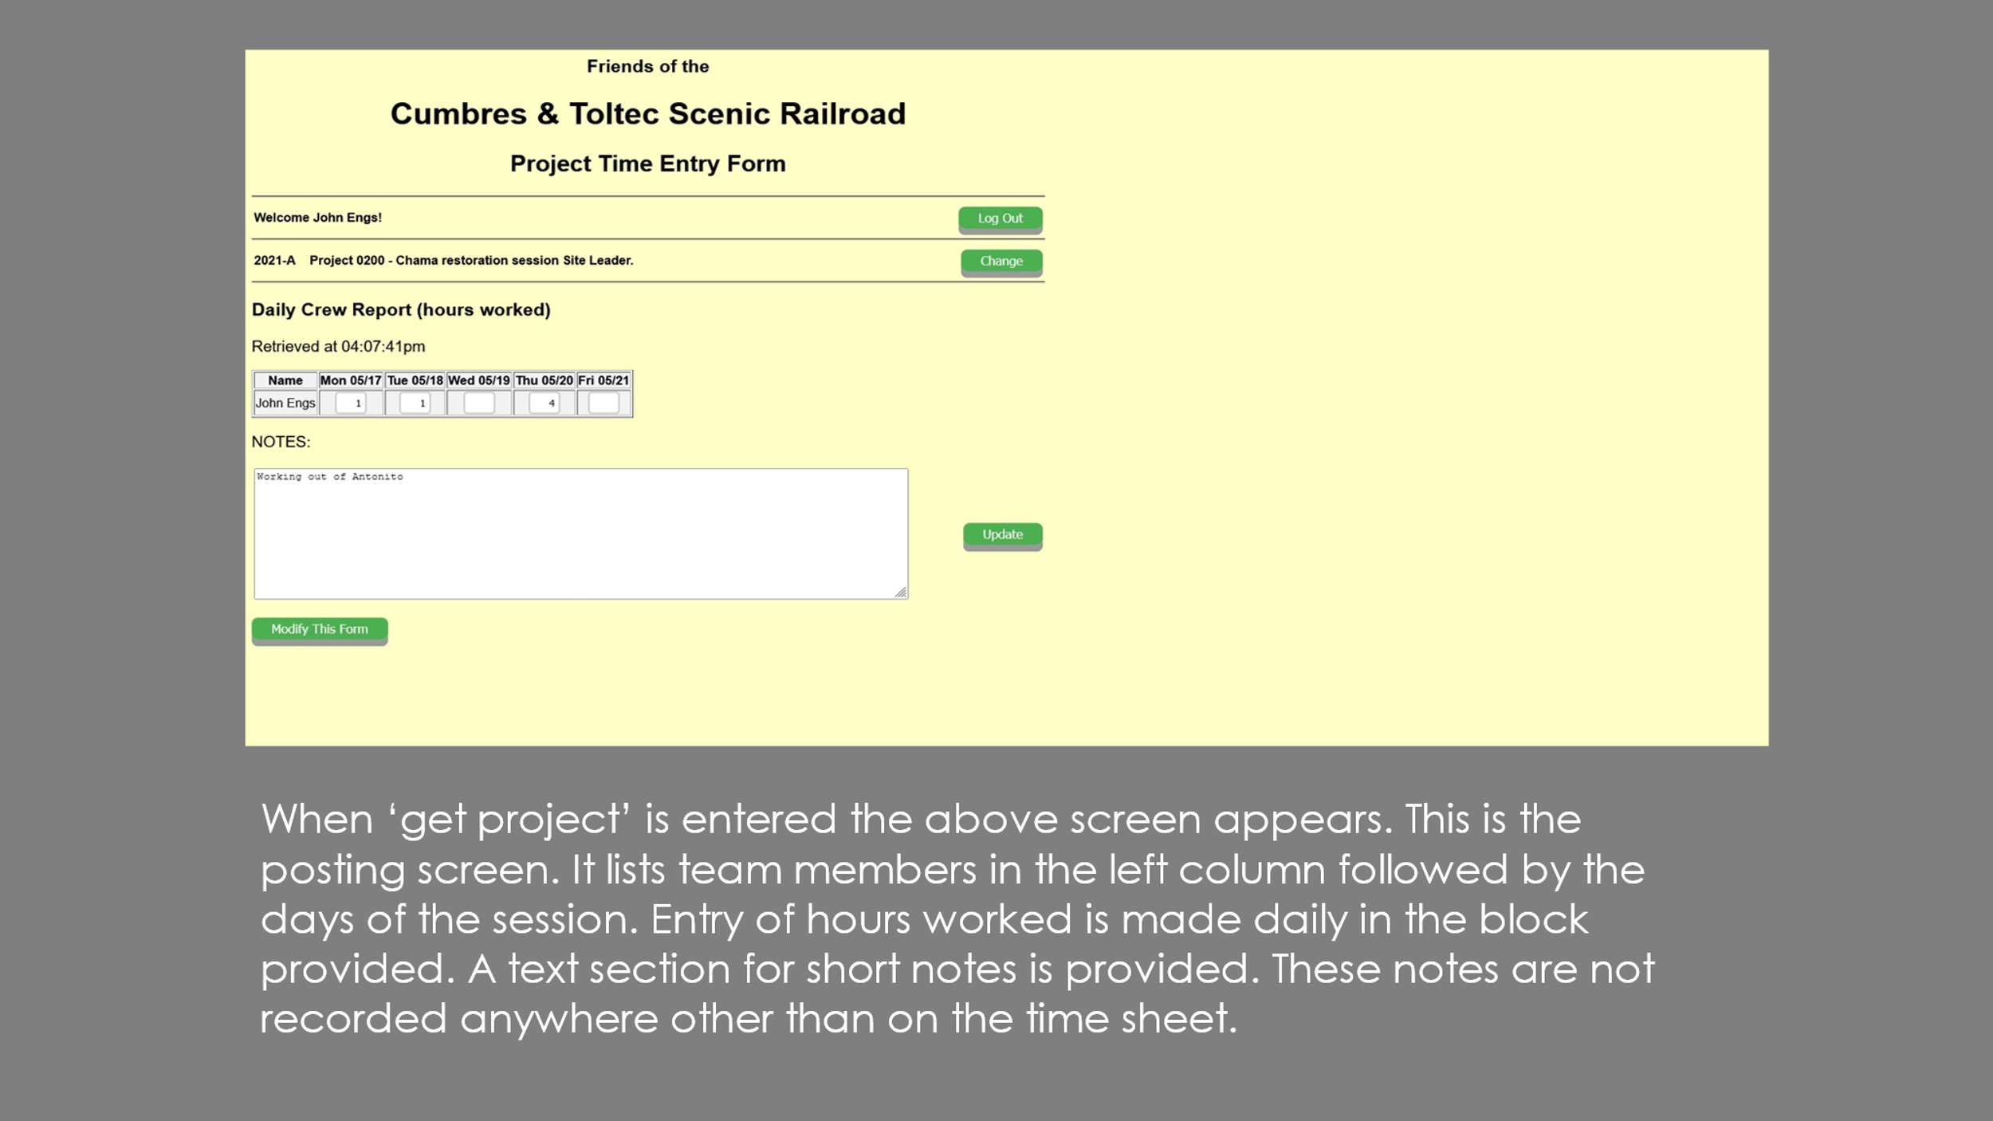Note that you are only allowed to post times for the project for which you were Team Leader or Alternate.

After ‘Get Project’ is selected, the time entry form appears. It lists team members in the left column followed by the days of the session. Hours should be entered on a daily basis in the boxes provided. There is a notes section which only relates to the hours worked. None of the information is transferred anywhere else.

The form may be modified which may be needed if any of the following applies:

* An extra crew member was added to the team
* A crew member didn’t work this project
* Extra days were worked on the project, either before or after, such as a Saturday or Sunday, or the project was shortened and days removed

Applying ‘Modify this Form’ button takes you to this screen which turns pink to indicate modifications in progress.

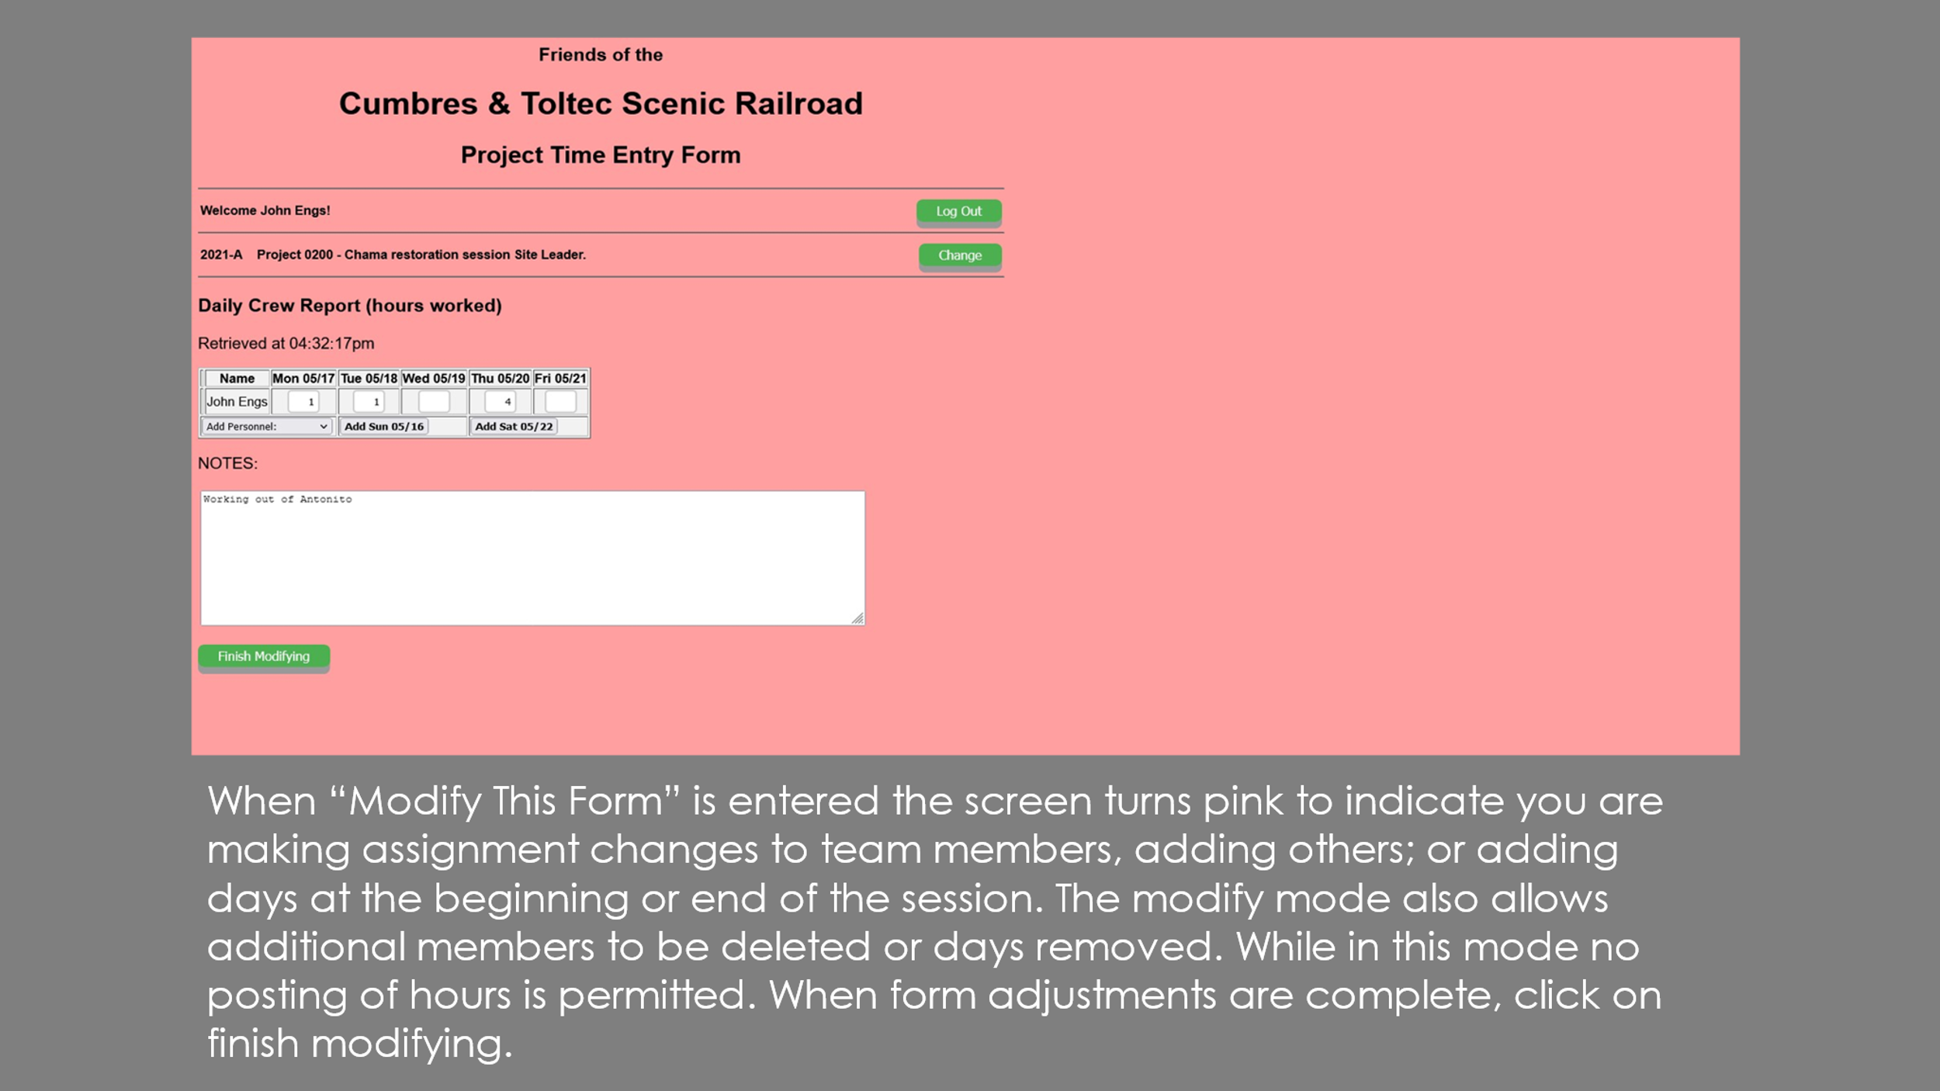

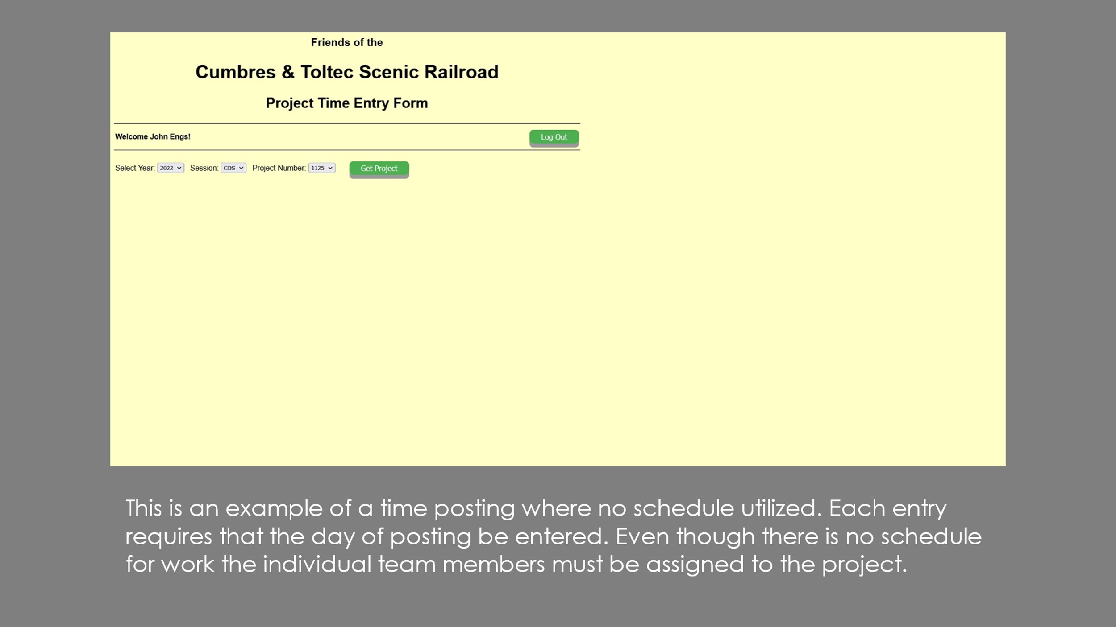When form adjustments are complete, click on ‘Finish Modifying’

